## **Course: Algorithm CS 435**

## **Prof. Prem Nair**

## **Student: Bereket Abraham ID: 109671**

## **Student: Robel Tesfamariam ID: 109706**

## **Student: Yosief Teklemariam ID: 109633**

## **Assignment: W3D2**

**Question 1.** Starting with the values 1, 3, 4, 4, 5, 7, 9, 11, 13, 13, 17, do the following:

1. Create a heap H in which these values are the keys by inserting one item at a time. You must show the heap after each insert both as a tree as well as array.

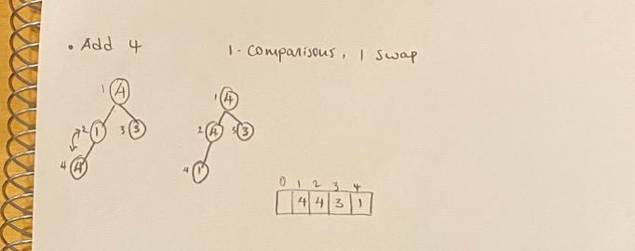

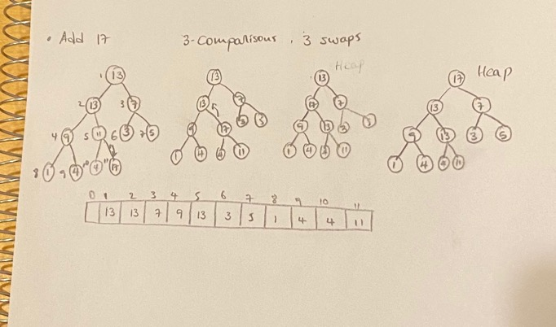

1. Create a heap H in which these values are the keys by the bottom up approach. You must show the heap after each insert each new value is placed in the heap in both as a tree and as an array.

1. Count the number of comparisons made in (a) **Answer:** 20
2. Count the number of comparisons made in (b) **Answer:** 20
3. Count the number of swaps made in (a) **Answer:** 8
4. Count the number of swaps made in (b) **Answer:** 8

**Question 2.** Carry out the array-based version of HeapSort on the input array [1, 5, 2, 11, 12, 2, 3].

**You need to first build the heap. You need not show all the steps. You are free to use methods mentioned in (a) or (b) of Question 1.**

Show all the remaining steps and outputs along the way.

**Question 3.** Given two Heaps H1 and H2 of the same height, give an efficient algorithm to “fuse together” to make one Heap.

Let say H1 is bigger heap.

Extract H2 elements one by one from the root and append into H1

Heapify H1

1. What is the best case?

If every element in H2 is smaller than or equals to the smallest element in H1

then no cost is needed for heapify. That means just basically append all

elements in H2 into H1.

1. What is the worst case?

All elements in H2 is greater than H1. Need to re-heapify

1. What is the worst-case time complexity?

Say, H1 has n elements, H2 has m elements

Time to append H2 into H1 O(m)

Time to re-heapify H1: O(n + m) with bottom-up approach.

Mr. Keletazghi’s report writing is so impressive and accurate. I know him better when he came to design team, he is hard worker, intelligent, and cooperative person. He prepared all his schedules properly and neatly. In addition to that he has always been committed and serious with his tasks. Of course, one would say that is typical of a software engineer, but he was superior to other engineers owing to the fact that he was smart, eager to learn new things and at the same time with a dedication to his work that surpasses the human whim for a constant change which accounts for his long stay, around five years. During these years, he has proved to be an excellent and efficient assistant to me, always punctual and cooperative.

I recall that Mr. Keletazghi was a diligent and devoted student. He used to make further readings in the course that I taught him and make the class lively with his brainstorming questions. Our department plans various researches and field trips where students see the applications on the ground of the principles they learn in class. There, Mr. Robel has also proved to be level-headed, cooperative and always attentive. When placed in group work session, Mr. Keletazghi easily adopted a leadership role, helping his peers learn how to solve problems on their own. Throughout Mr. Keletazghi modeled excellent problem solving and critical thinking skills.

Mr. Keletazghi is an outstanding employee who on a daily basis goes “above and beyond” in his command and support to the workers that worked with him and continuously exceeds the performance standard for his position of software engineer. Mr. Keletazghi willingly accepts new assignments and offers to help wherever he can. He is an extraordinary employee and a vital member of the team in the working field. He is attentive to tasks and works nonstop to achieve the goals of the department. He is an extremely positive and dependable employee, and performs his duties in an extremely timely and conscientious manner.

I am sensationally empower to decree an employment letter for Eng. Keletazghi Tesfazghi who has been active member of our company Liya Enterprise currently working as Java developer, Asmara Eritrea. He is a valuable asset to our company Keletazhgi Tesfazghi is a hard, courteous goal oriented individual who can up hard the reputation of our company and give it a promising future. His overall responsibility was to enable smooth and efficient operation and I am pleased to say that he performed this task with the utmost competence.

Finally I wish him success in his studies. I f you need any further information regarding Eng. Keletazghi please feel free to contact me.